
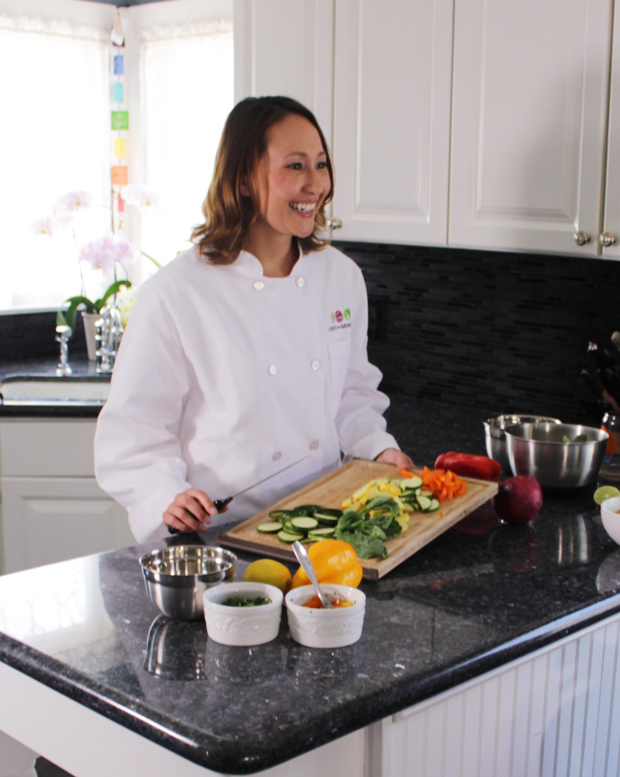


Sample Personal Chef Business Plan

The Business Plan Outline
The knowledge you gain from the exercise of writing a business plan is invaluable, and your efforts will pay off when your personal chef business is operational. This sample business plan is the same one we give to franchisees at Chefs For Seniors.

First, you need to start with an outline and fill it in with details. The outline below offers a complete checklist for management of a personal chef business.

Business Plan Outline

- Executive Summary
- Business Description
- Service Description
- Marketing and Sales Plan
- Operational Plan
- Financial Plan

Executive Summary
The executive summary is perhaps the most important element of a business plan, especially if you’re looking to acquire financing. It’s the first thing someone looking at your business plan is going to read, and the goal is to entice the reader to take the time to go over the rest of the plan in detail. While the executive summary is the first part of your business plan, most people write it last.

The points you should cover in the executive summary are:

- The current status of your business, such as when it was started or when it’s expected to begin operating
- Brief introduction of the owner(s) – overview of education and experience
- Description of the service provided
- Information on your target market
- Marketing strategy
- Financial projections
- Amount of money, if any, you are seeking from investors

Condensing all that information into a 1-2 page summary isn’t easy, but you can do it if you stay focused on the key information. Remember, it’s suggested you write the executive summary last.

Business Description
This section should define what your business does and its purpose. Your company mission, financial goals, information on company ownership, and legal structure are good things to include.

Service Description
Personal chef businesses are an innovative, revolutionary concept. Therefore, in this section it’s important to clearly identify the nature of your business and the services you provide in this section.

Marketing and Sales Plan
If you want to succeed in business, you have to get consumers to buy from you. That’s where marketing comes in. Primary objectives of this section are:

- Defining your target market in your area – who are the potential clients?
- Develop a pricing structure that will provide value to your clients and ensure maximum profitability for your business.
- Determine what combination of advertising, publicity, and personal selling to use to promote the business.

When writing your marketing and sales plan, try being as specific as you can, basing your strategy on realistic assumptions.

Operations Plan
In this section, you’ll describe how your service will actually be performed.

Financial Plan
This is the section of your plan that most lenders and investors (even friends and family who fund your business) consider the most important. You’ll provide financial information such as projected revenue, breakeven point, and capital (if any) required. If you need financing, you may need to create pro-forma statements that show revenue and expense projections over a 3-5 year period.

Sample Business Plan
This is a sample business plan you can use to guide you through the process of writing one for your personal chef business. Your plan will likely be more detailed. Don’t pay much attention to any specific numbers used; they will be different for each market and business owner’s goals/objectives.

Sample Business Plan
XYZ Personal Chef Service, LLC

Executive Summary:
XYZ Personal Chef Service is structured as a Limited Liability Company (LLC), and will offer a service preparing customized meals for older adults in their homes. The owner-operator, Chef XYZ, is a graduate of ABC Culinary School with over a decade of experience working in fine dining establishments as a professional chef.

The primary target market of XYZ Personal Chef Service will be {insert target market info, such as demographics and psychographics}.

On a service day, Chef XYZ will shop for all grocery items and bring all the necessary cooking tools into the client’s home. In about two hours, Chef XYZ will prepare make-ahead meals based on the client’s specific dietary concerns and food preferences, while at the same time engaging in friendly conversation. Most clients will use the service on a weekly or bi-weekly basis. For this service, XYZ Personal Chef Service will charge $X plus the cost of grocery for # servings of meals.

This business will generate community awareness using a combination of {insert marketing channels your business will focus on}.

After a year of operation, XYZ Personal Chef Service expects to generate gross service revenues (minus grocery sales) of $X, resulting in a gross profit of $Y. {You may want to attach a pro-forma with projected financial statements}

The company will operate in a manner projecting a clearly professional, caring, meal service and so each client feels like he/she has an exclusive Personal Chef.

Business Description:
XYZ Personal Chef Service is an innovative service aimed at {insert mission statement}. Chef XYZ will offer fairly priced, customized menus using only the freshest ingredients for senior clients. This service solves a significant problem for seniors wanting to remain in their homes, but struggle to prepare healthy meals for themselves.

The company is structured as a Limited Liability Company (LLC) and operated from home to control overhead expenses. Office space will be set aside in the home and used exclusively for business purposes. The company will have its own telephone number, and all administrative work will be taken care of in the office space. A professional image will be projected through branded brochures, business cards, miscellaneous marketing materials, online presence, and professional manner.

The company will obtain the proper business licenses for maintaining a business office in the home, and a ServSafe Food Manager’s certificate.

Service Description:
XYZ Personal Chef Service will offer a standard service of # servings of meals for an individual, couple, or family. The service will be available as weekly, bi-weekly, or monthly service. The frequency of service will determine how meals are stored, in the refrigerator or freezer. Menu items will be constructed to meet clients’ specific tastes and dietary concerns, taking inspiration from proven recipes. Items offered will also change seasonally. The company will charge $X plus the cost of grocery, with a $Y surcharge for heavily customized diets.

Marketing Plan:
XYZ Personal Chef Service will advertise the service using a well thought out marketing plan. The goal is to obtain maximum exposure within the XYZ service area by spending an average of $X/week on marketing during the initial startup phase.

XYZ Personal Chef Service will generate community awareness using combination of direct sales, press releases, client referral programs, and materials distribution to area hospital discharge planners. Special promotions will also be used to encourage potential clients to try the service. A local graphic design firm will design custom marketing materials.

The primary target market of XYZ Personal Chef Service will be {insert target market info}.

XYZ will offer the service in the communities of {insert cities}.

Operational Plan:
Once a potential client expresses interest in the service, Chef XYZ will make an appointment for a no-cost Initial Consultation. Chefs XYZ will go to the client’s home and discuss the advantages of the service offered. If they are interested in trying the service, clients will sign the services agreement, and fill out a questionnaire highlighting ingredient likes/dislikes. While the client is finishing the questionnaire and reviewing the services agreement, Chef XYZ will examine the kitchen, taking note of non-perishable ingredient inventory. Finally, a menu will be decided on for the first service day. Consultations can also be conducted over the phone if it’s more convenient for Chef XYZ and the client.

On the service day, Chef XYZ or a personal chef employee will pack all necessary equipment and shop for ingredients at a local grocery store. The shopping process will typically take ~30 minutes.

Once shopping is completed and the chef arrives at the client’s home, ingredients will be unpacked. Ingredients will be prepped, using different cutting boards for meat and vegetables.

After prepping is complete, the menu will be prepared as planned in a # hour period. When all meals have been prepared, the client will be asked to taste each item to ensure satisfaction, and dishes will be stored in individual containers. Containers will then be labeled with the name, date, and reheating instructions if necessary. Depending on the frequency of service, items will be stored in the refrigerator and/or freezer.

Finally a menu for the next service day will be selected and the grocery receipt will be left with the client. Payment will be collected upon completion of the service.

Financial Plan:
Personal Chef Service XYZ will require $X of startup capital which will be self-funded. The company plans to start showing a profit within the first X months, and will recoup the initial investment after X service days.

If services are performed for X clients/week, the company will generate gross revenues of $Y with a X% profit. XYZ Personal Chef Service estimates needing X clients in total to achieve the necessary number of services each week. To account for client churn, the company will need to generate X new clients each month.

